GWC Schedule (2017)

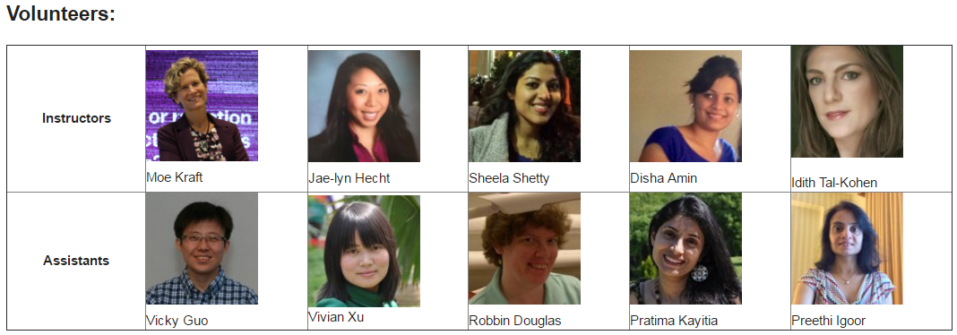
Name | Email | Contact#
Himani Patel | patel_taru164@yahoo.com | 508-838-8077
Virginia Shea | stanleyshea@comcast.net | 978-486-3053
Adharsha Ramesh | adhiram04@gmail.com | 617-447-0117
Stephanie Sutton-Brown | david.sutton.brown@gmail.com | 978-340-4588

